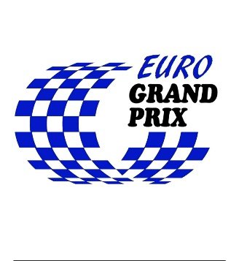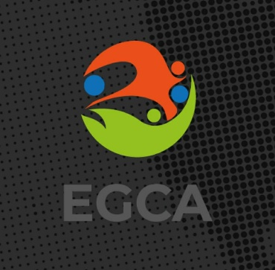

EUROPEAN GRAND PRIX CENTRAL 2023
Time: 23rd - 25th June 2023
Place: Utrecht, The Netherlands
Head organizer: USV Hercules-Goalball

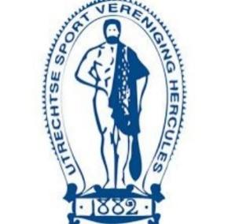

Dear Goalballfriends

USV Hercules is excited to invite you for a new edition of the European Grand Prix. We will welcome you in our beautiful city Utrecht
The tournament will be from June 23rd till June 25th 2023.

We are inviting all goalball clubs of countries in the Central Region: Austria, Belgium, Czech Republic, Germany, Hungary, Netherlands, Poland, Moldova, Romania, Slovakia, Switzerland, Ukraine to take part in our tournament. But don’t hesitate to register for the tournament when you live in another part of Europe and want to come to Utrecht

For more information about registration and regulation see on EGCA website. www.egca.info

Preliminary schedule
Friday June 23rd 2023: Arrival of teams
18.00 Opening Ceremony
First games of the tournament
Saturday June 24th 2023: Competition day
Sunday June 25th 2023: Competition day and medalgames
15.00 Closing ceremony and departure of the teams

Venue
The tournament will be played at sports hall of USV Hercules
Floor material of the play court is a smooth surface floor.
There are dressingrooms.

Accommodation & meals
Teams and referees will be accommodated at Hotel Mitland in Utrecht at about a 10 minutes walk from the venue. We will have breakfast in Hotel Mitland. Lunch and dinner will be served at the Paviljoen of USV Hercules at the Venue

Entry fee
Entry fee is 200 € / person from Friday to Sunday and it includes:
- Transportation between the airport and the hotel;
- Accommodation from Friday to Sunday at Hotel Mitland in double or triple rooms;
- Meals (breakfast, lunch and dinner) from Friday dinner to Sunday lunch.

The nearest airport is Schiphol Airport Amsterdam ( AMS)
We can individually calculate costs from other airports as Eindhoven Airport

Extra night cost €125,= for a double room excl. tourist taxes.

Insurances
Please take care that all the members of your team have own valid insurance during the tournament. If some injury happened we will help you to get first-aid and transfer injured person to the hospital.

Covid
You can arrive to the Netherlands from European Union and Schengen countries without any requirements or restrictions. Because of Covid is still part of our life there may be still some covid rules during the tournament (they will be announced in information package of the tournament).

Deadlines
- February 15th 2023: registration will be open;
registreren via de link: https://docs.google.com/forms/d/e/1FAIpQLSe6AYsEVDmcXjPM9CwifK39i3jBLepVBabnMobfknIWLdUNdw/viewform?fbclid=IwAR2Q3_h7Jw8P4ptt0PJdU86TC1H-v08S-H9P9PwWz2Iaryjw758KUrn5mq8

- April 1st 2023: registration will be closed;
- April 5th 2023: participating clubs will be published by EGCA, entry form and invoice will be sent to the clubs by the organizer;
- April 28th 2023: entry form will be returned and participation fees paid by the clubs;
- June 15th 2023: information package, game schedule and team line-ups will be announced on EGCA website and sent to the clubs.

If you have some questions don't hesitate to contact us
Our contact: Koosje van Zweeden
ikgoalball@hotmail.com
Whatsapp: +31638850576

Or our Tournament Director: Jolanda Spaans
Ikgoalball@hotmail.com

We hope to welcome you In Utrecht at Euro GP!

